Module Name: Selenium Web Automation
Test Case ID: 183
Webpage URL:"https://techbeamers.com/selenium-practice-test-page/"

● Scenario ID: 14a
Scenario: Browser Navigation
Test Steps:
- Open PyCharm IDE.
- Open the Selenium Web Automation project.
- Open the script1.py Python file.
- Import the Selenium WebDriver module.
- Create a Chrome WebDriver object.
- Open the TechBeamers Selenium Practice Test Page.
- Maximize the browser window.
- Verify the current webpage URL.
- Navigate to the TechBeamers Practice Login page using Selenium WebDriver.
- Verify that the login page is opened successfully.
- Use the Selenium browser Back operation to return to the previous page.
- Verify the Selenium Practice Test Page is displayed again.
- Use the browser Forward operation to return to login page.
- Refresh the current page using Selenium WebDriver.
- Verify that the page remains accessible after refreshing.
- Display the test results in the PyCharm console.
- Close the browser after completing the test.

Screenshots: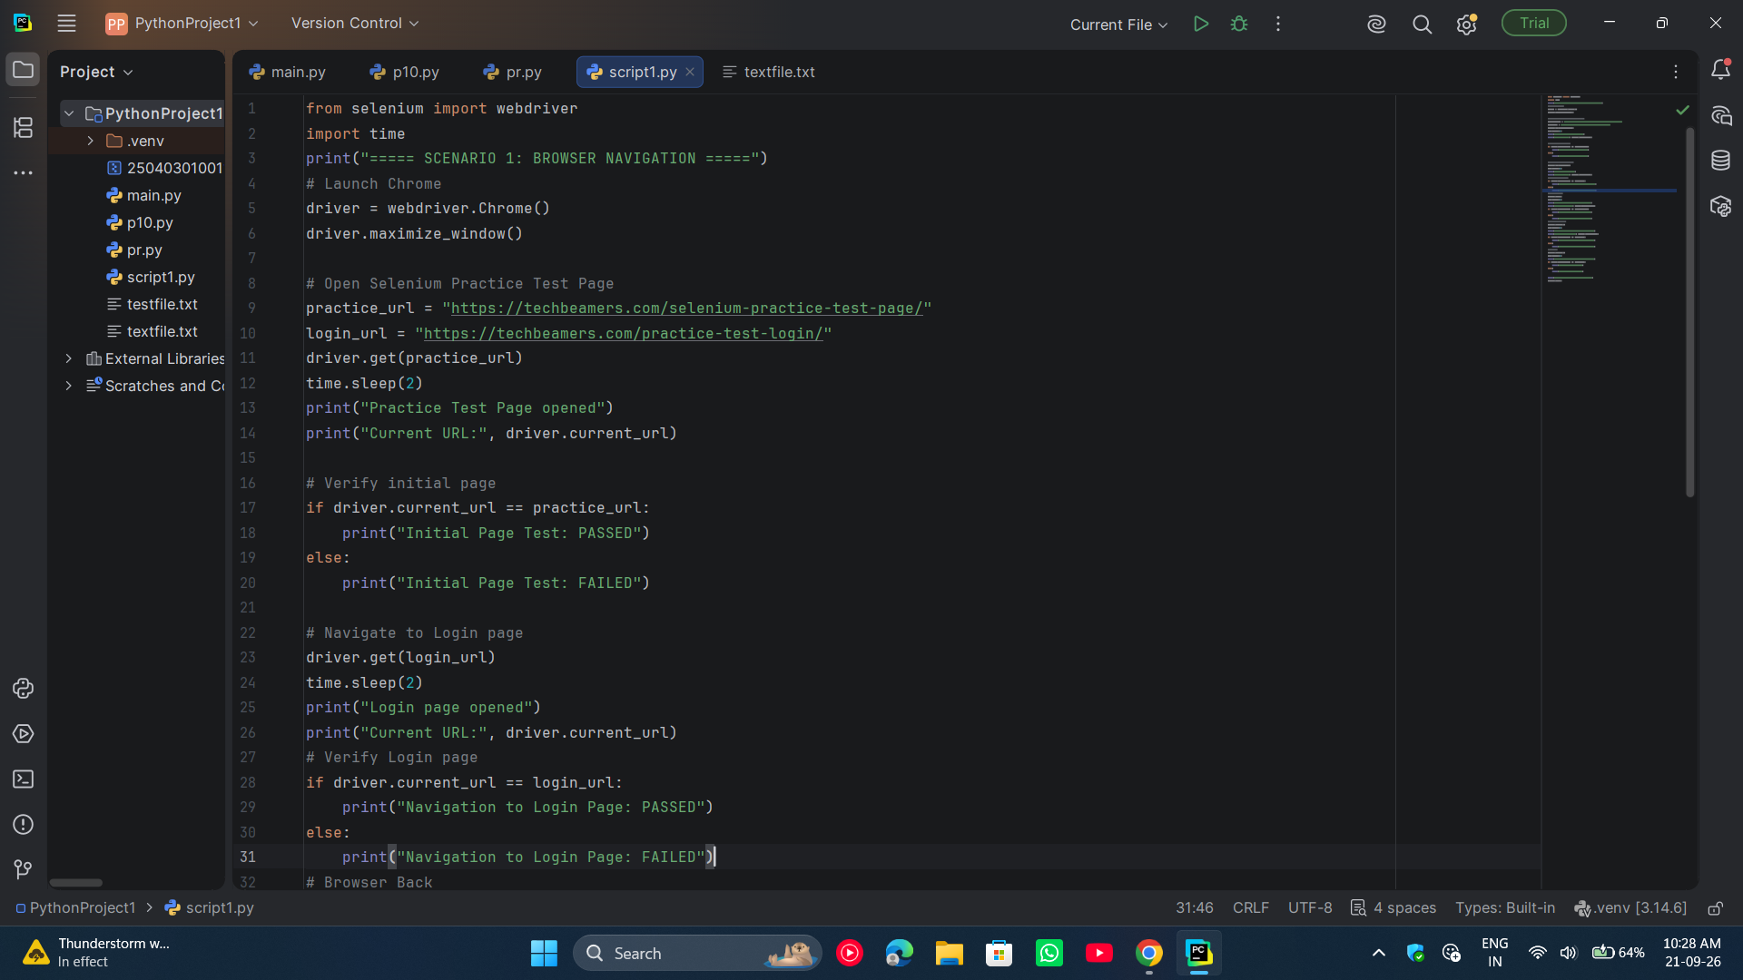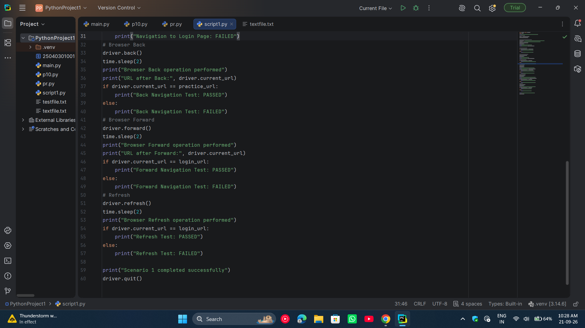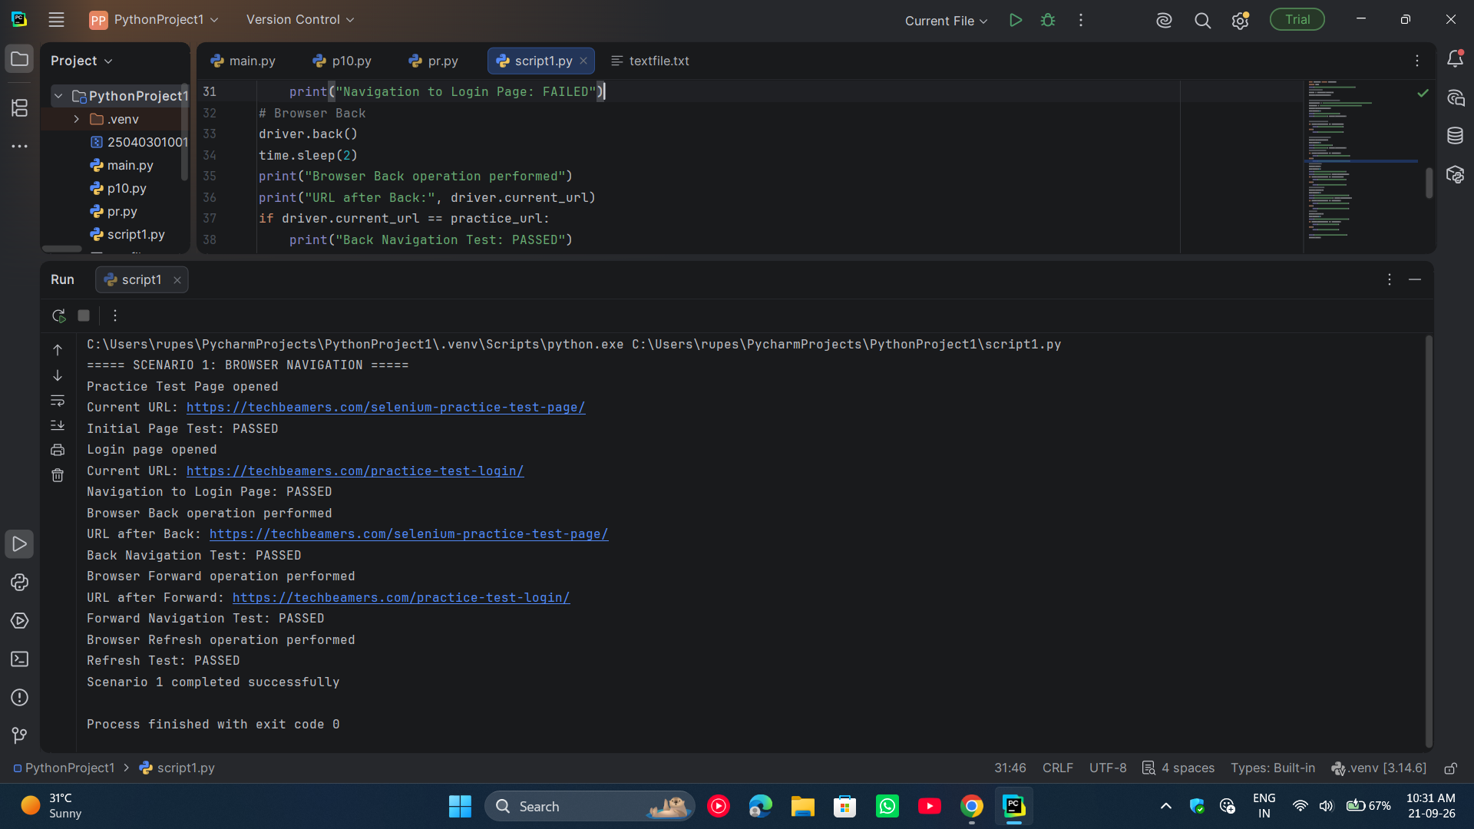

● Scenario ID: 14b
Scenario: Form Handling
Test Steps:
- Open PyCharm IDE.
- Open the existing SeleniumWebAutomation project.
- Open the script1.py file.
- Import Selenium WebDriver and the required Selenium modules.
- Create a Chrome WebDriver object.
- Open the TechBeamers Selenium Practice Test Page.
- Maximize the browser window.
- Locate the Username field and enter the test username.
- Locate the Email field and enter a valid email address.
- Locate the Password field and enter a valid password.
- Locate the Bio field and enter sample text.
- Locate the Country dropdown.
- Select a country from the dropdown.
- Verify that the entered form data is present.
- Click the Submit Form button.
- Verify that the form submission message is displayed.
- Display the test result in the PyCharm console.
- Close the browser after completing the test.
Screenshots:
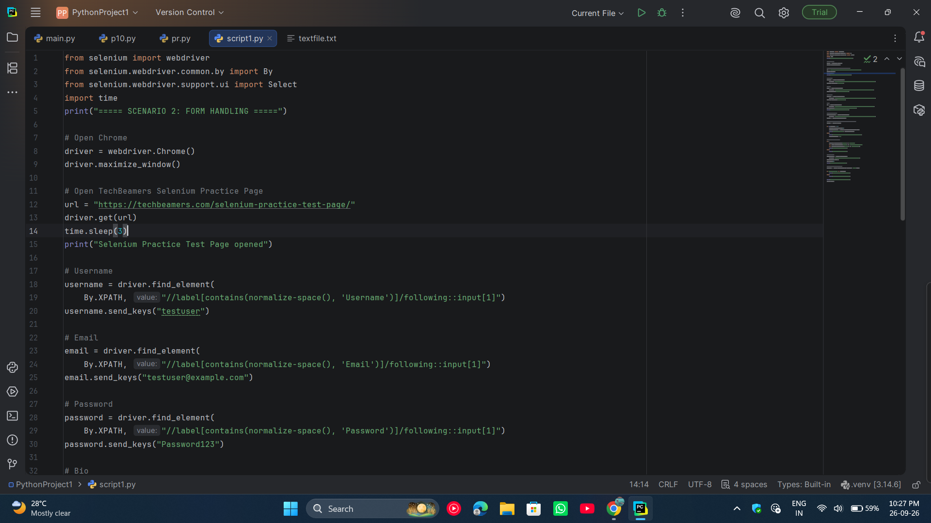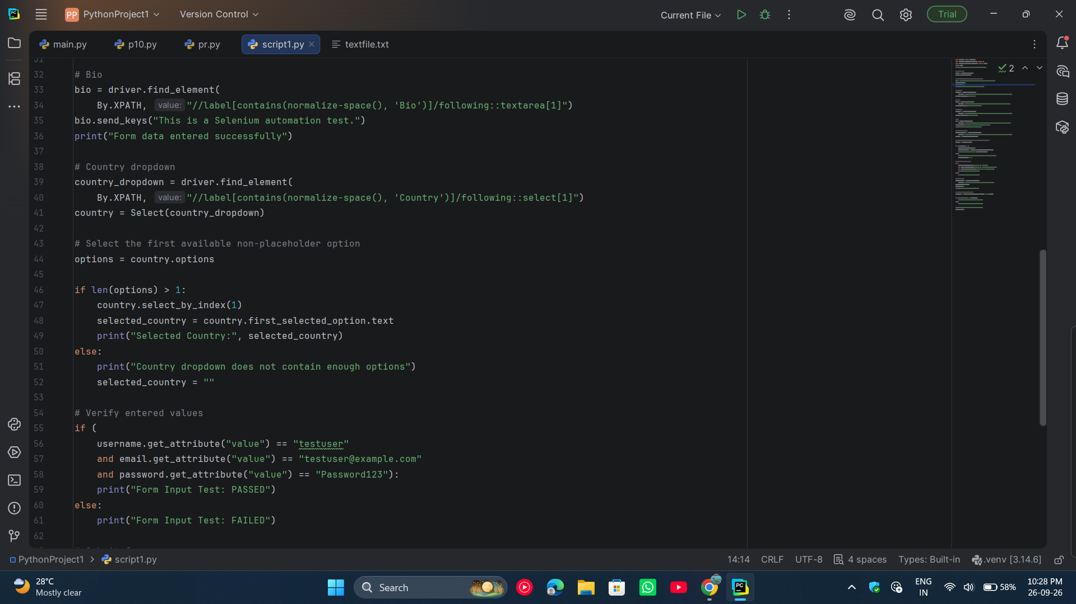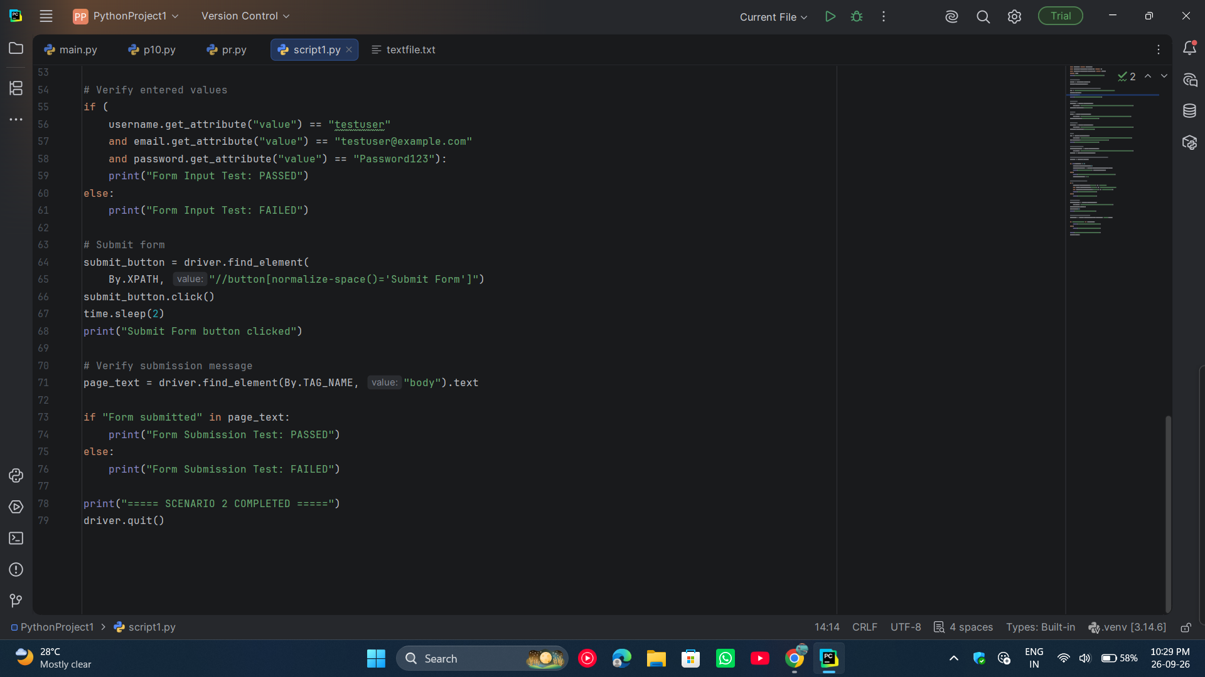

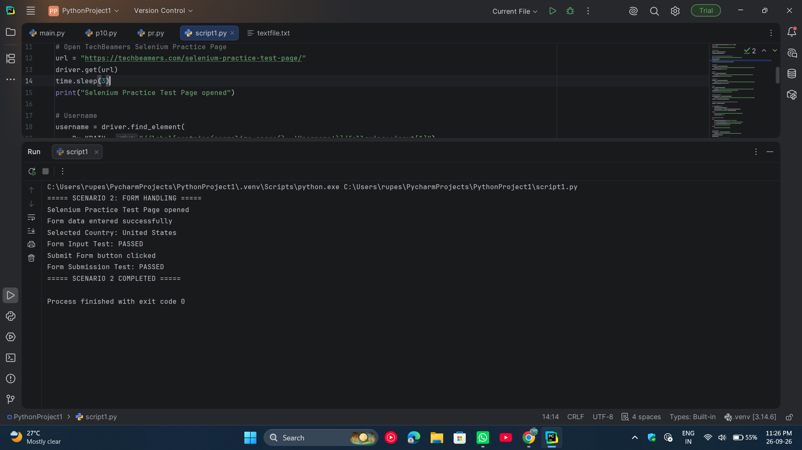

● Scenario ID: 14c
Scenario: Web Element Interaction
Test Steps:
- Open PyCharm IDE.
- Open the existing SeleniumWebAutomation project.
- Open the script1.py file.
- Import Selenium WebDriver and the required Selenium modules.
- Create a Chrome WebDriver object.
- Open the TechBeamers Selenium Practice Test Page.
- Maximize the browser window.
- Locate the Sports checkbox.
- Click the Sports checkbox.
- Verify that the Sports checkbox is selected.
- Locate the Music checkbox.
- Click the Music checkbox.
- Verify that the Music checkbox is selected.
- Locate the Male radio button.
- Click the Male radio button.
- Verify that the Male radio button is selected.
- Locate the Female radio button.
- Click the Female radio button.
- Verify that the Female radio button is selected and the Male radio button is no longer selected.
- Locate the Reset button.
- Click the Reset button.
- Verify that the selected form elements are reset.
- Display the test results in the PyCharm console.
- Close the browser after completing the test.
Screenshots: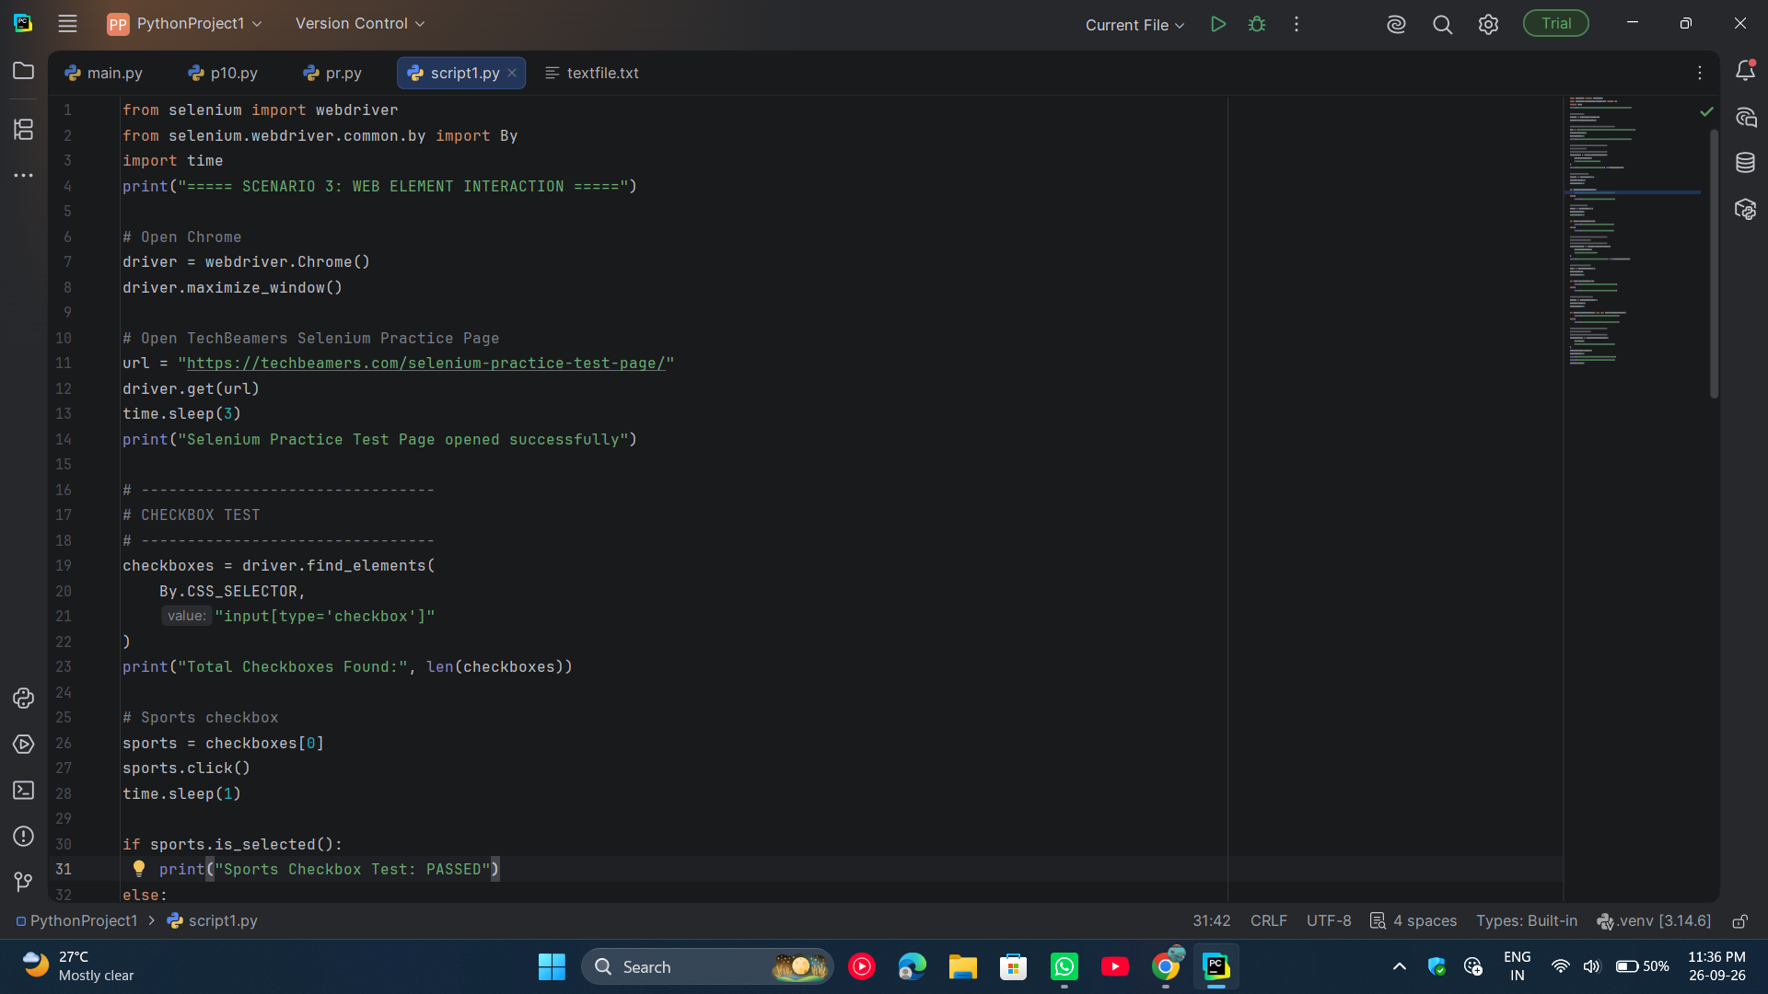
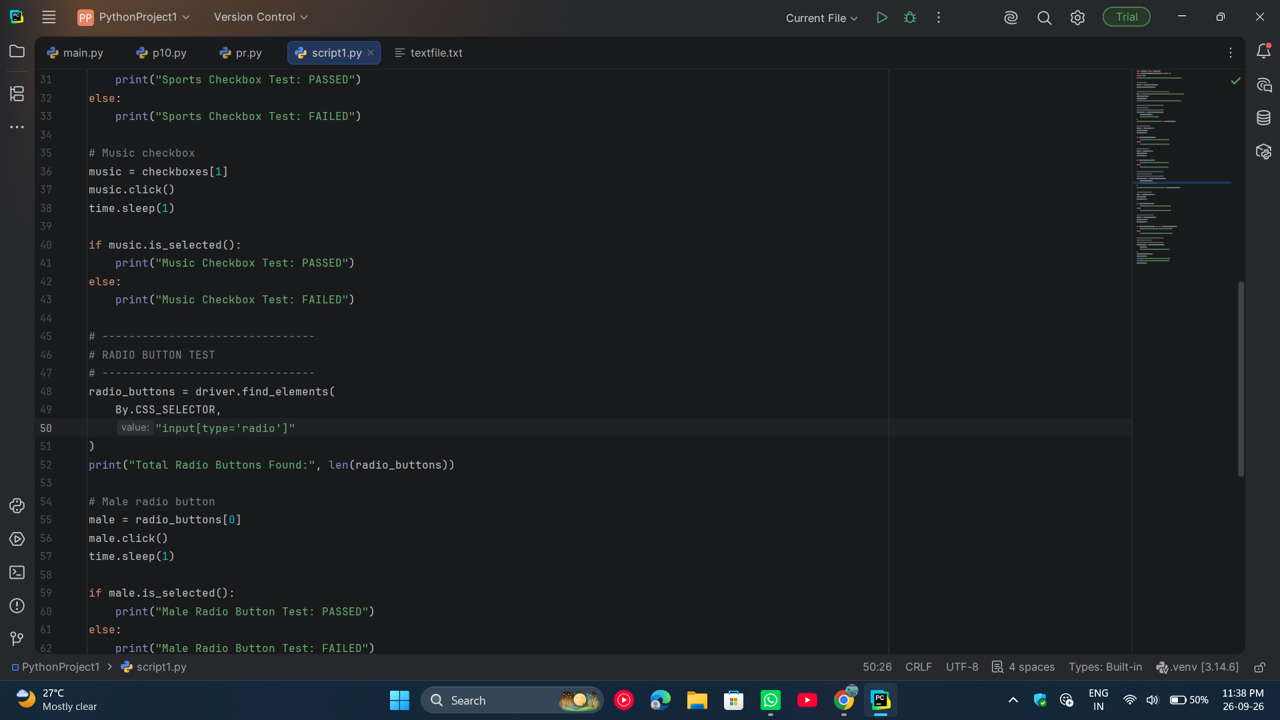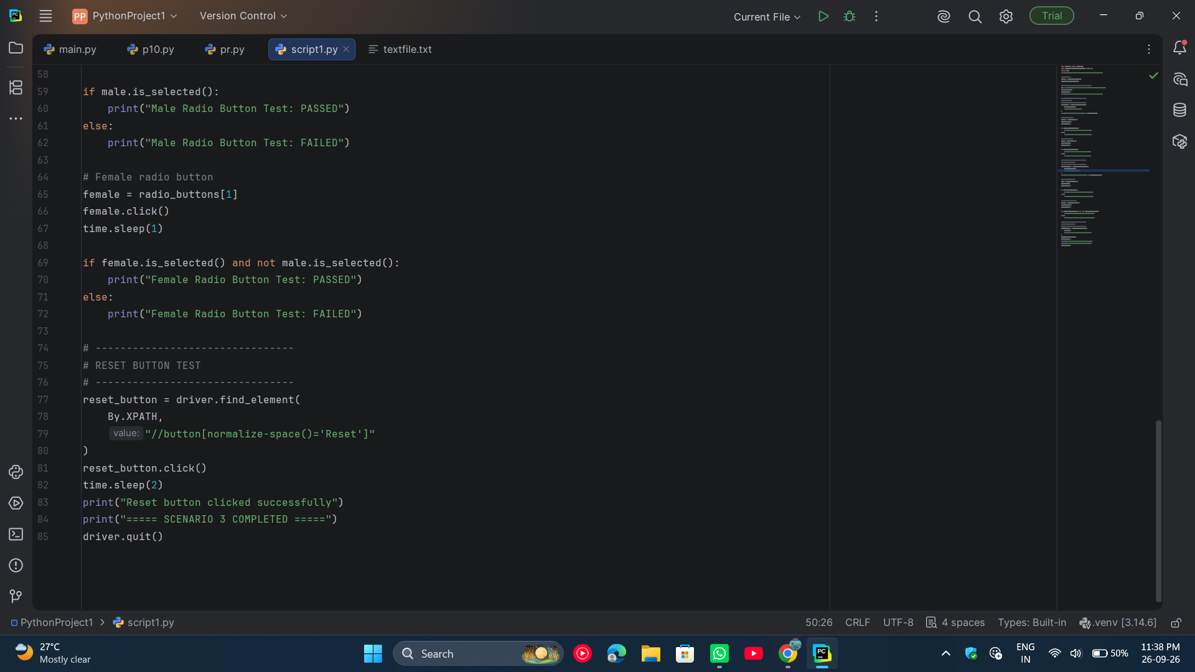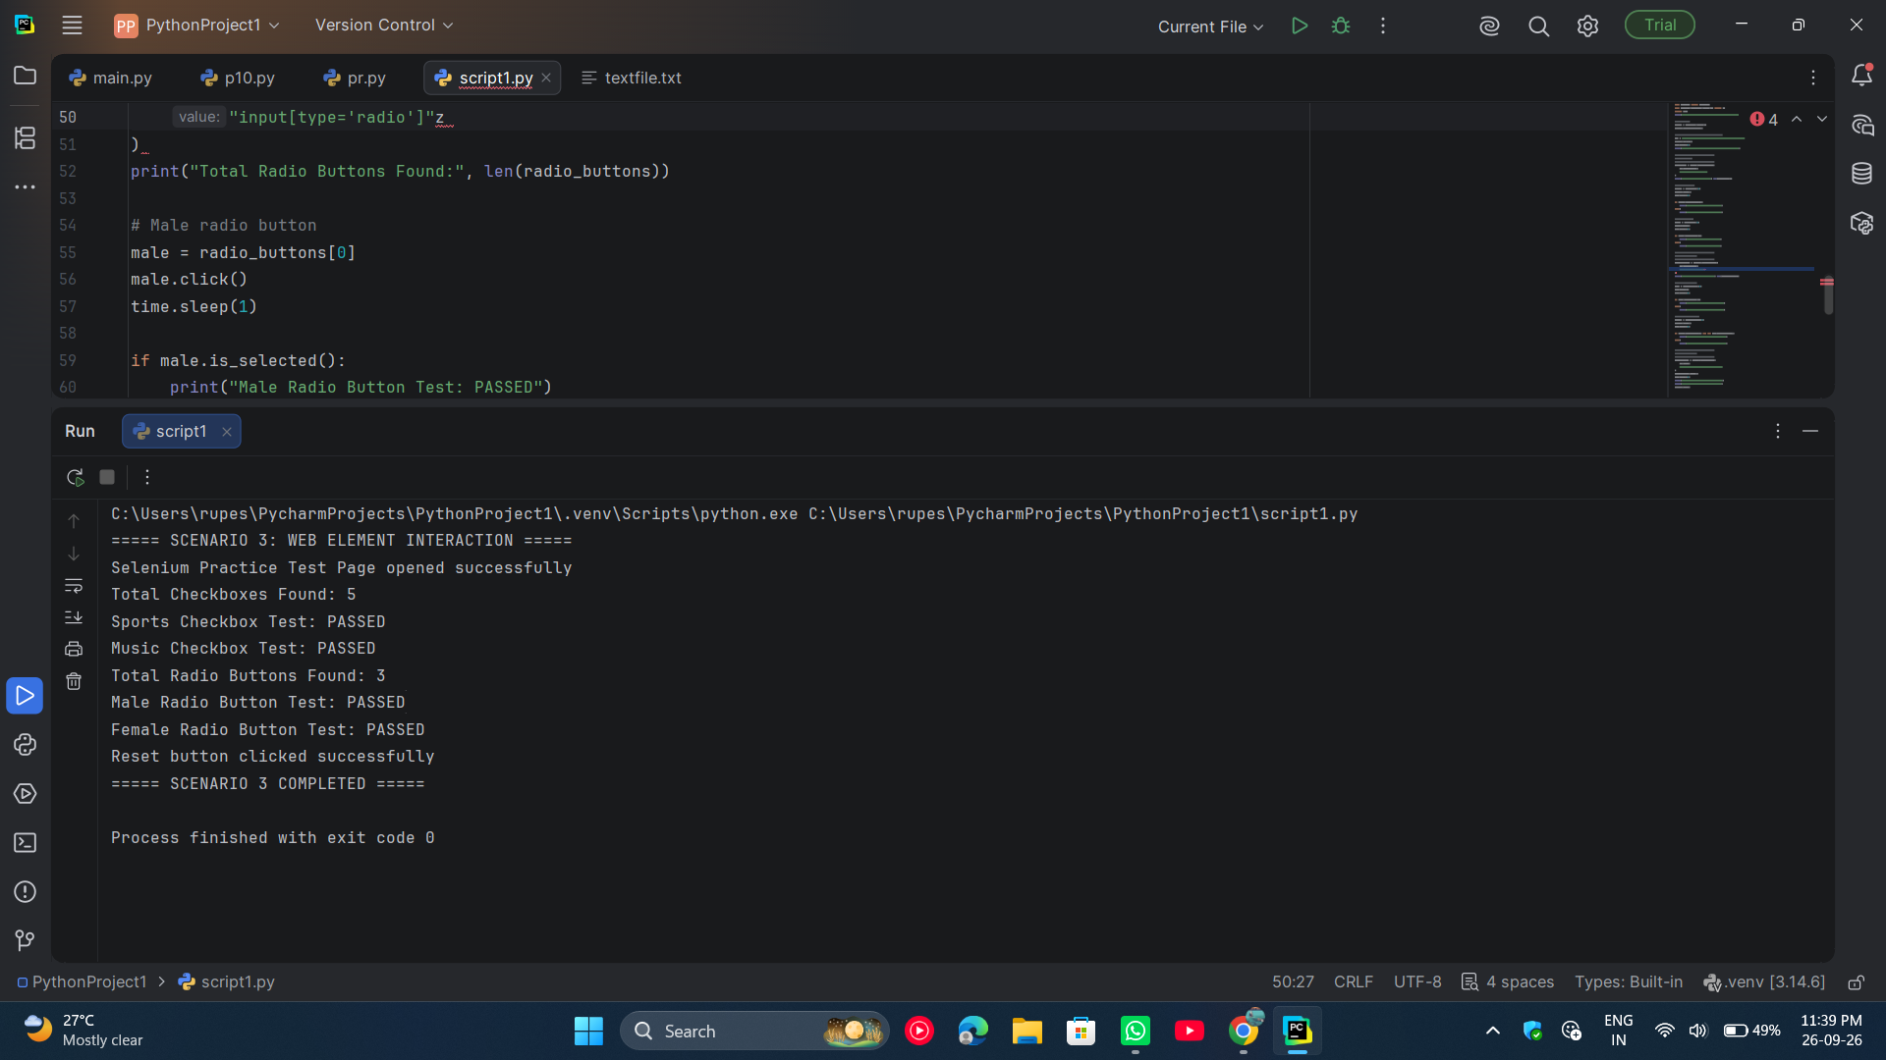
● Scenario ID: 14d
Scenario: Validation Testing
Test Steps:
- Open PyCharm IDE.
- Open the existing SeleniumWebAutomation project.
- Open the script1.py file.
- Import Selenium WebDriver and the required Selenium modules.
- Create a Chrome WebDriver object.
- Open the TechBeamers Selenium Practice Test Page.
- Maximize the browser window.
- Locate the Username, Email and Password fields.
- Enter an invalid username containing fewer than 3 characters.
- Enter an invalid email address.
- Enter a password containing fewer than 8 characters.
- Verify the validation state of the entered values.
- Clear the invalid values from the form fields.
- Enter a valid username.
- Enter a valid email address.
- Enter a valid password containing at least 8 characters.
- Verify that the valid input satisfies the field validation rules.
- Click the Submit Form button.
- Verify that the form is submitted successfully.
- Display the validation test results in the PyCharm console.
- Close the browser after completing the test.
Screenshots: